RHEL 8 HA (Vanilla) Automation - Detailed Design
Oct 30, 2026 · @Satish Gurushanthappa

1. Purpose, scope and assumptions
This design automates the customer SOP "RHEL 8.x HA (Vanilla)" as one AAP job that builds two RHEL nodes with the existing standalone roles, then forms and validates a two-node Pacemaker/Corosync cluster with new roles.
In scope
- Allocation, provisioning and configuration of two nodes by reusing the standalone aap.shared.* roles (reused as-is or with small backward-compatible changes).
- A generic HA core (cluster, fencing, quorum, resources, shared storage, validation) that carries no client names, so it can be reused elsewhere.
- A VMware adapter (DRS anti-affinity, shared disk) and a client orchestration layer (main.yml, stage runner, failure mails).
- Resume and failure conventions identical to the standalone framework (failmsg, failmail, sucmail, extra_vars).
Out of scope for v1
- More than two nodes, qdevice, and the ha_cluster system-role backend (the switch is reserved, not built).
- Application resources beyond a dummy/example resource, and automating the vSphere HA VM override (manual step).
- Windows roles and any change to the standalone behaviour.
Assumptions (to be confirmed; see section 15)
- VMware on two vCenters, one per datacentre; Gold/Silver/Bronze tiers selected by role 04.
- AAP supplies credentials through custom credential injectors (environment variables) and a Machine credential for SSH.
- Role code that has not been reviewed yet behaves as its guard in site.yml and the role/task mapping suggest.

2. Context: what the standalone framework forces on the design
The standalone workflow builds one VM per run from global facts guarded by <flag> is none, and every HA design choice below follows from that.
Framework fact | Evidence | Design consequence
One play on localhost, about 36 include_role tasks, each guarded by its own output flag and by failmsg == nomsg | site.yml | The guards double as resume switches. A loop over two nodes would skip node 2.
All state is global facts: about 35 variables, null by default | standalone defaults/main.yml | Each node needs its own fact scope.
Every role wraps its work in block/rescue that sets failmsg (HTML addressed to the owning team), failmail: true, sucmail: false | roles 04, 06, 10, 95 | New roles must follow the same convention, through one shared stage runner.
Resume is done by editing extra_vars named in the failure mail | rescue text of roles 04, 06, 10, 95 | extra_vars are job-global, so per-node resume needs a node-scoped structure.
Role 03 derives the name from the AAP job ID (step 10) into the global servername | role 03 vars and template | Two calls in one job collide. Pair names are explicit inputs.
Role 04 picks the datacentre by the parity of the trailing digits of servername | role 04 | Run once per cluster, so both nodes land in the same DC and vSphere cluster.
Role 10 creates the VM powered off, passing only the cluster to vmware_guest (no ESXi host) | role 10 | DRS places the VM, so the anti-affinity rule must exist before the first power-on.
Role 06_host_selection sets hostname and host_valid, but nothing reads them | site.yml, role 10 | The capacity check is advisory. It cannot separate the nodes.
Role 95 posts one server and one IP; role 97 shows one server | roles 95, 97 | Repackage both for a pair; call them once per request.
Credentials arrive as environment variables from AAP injectors (vCenter 1 and 2, SMTP, CloudStudio) | roles 06, 10, 95, 97 | New roles read the same way and never put secrets in extra_vars.
Code has been read for 7 of the roughly 38 roles. Verdicts for the others rest on their guards in site.yml and the role/task mapping; the Reuse Map workbook marks which is which.

3. Design principles and key decisions
The design reuses what already works, adds only what a cluster needs, and keeps the standalone failure and resume convention intact. Each decision below has a cost; the cost column is the part to challenge.
# | Decision | Why | Cost / risk
D1 | Reuse the standalone roles unchanged, called from a thin wrapper (39_rhel_node_build) with the same guards as site.yml | No fork to maintain; fixes in a standalone role reach HA automatically | Inherits their quirks (global-fact assumptions, one VM per run)
D2 | One virtual build host per node (<node>-build, connection local) | Gives each node its own fact scope, so the <flag> is none guards work per node | Unproven with the real roles: needs the isolation spike (section 15)
D3 | One stage runner (ha_stage) wraps every new role in block/rescue and writes failmsg/failmail/sucmail | New roles behave like the old ones: same mail, same resume by extra_vars | One more layer to read when debugging
D4 | Gates after every per-node phase aggregate failures, and catch hosts that never reached the phase marker | A node that dies silently cannot let the cluster build continue | Gate must be kept in sync when phases are added
D5 | Hand-rolled pcs backend (ha_backend: pcs); the RHEL system role is reserved, not built | Exact control over error messages, idempotence and ordering | More code to own than the system role
D6 | Fencing is mandatory: fence_vmware_rest by default, fence_scsi allowed, none only in lab mode | Shared storage without fencing corrupts data | Needs a vCenter service account and a reachable vCenter from both nodes
D7 | Fence password never enters the CIB: root-only script on each node reads it | CIB is readable by the haclient group | Script must be delivered and rotated by automation
D8 | Two-node quorum (two_node + wait_for_all), no qdevice | Simplest supported topology; fencing is the arbiter | A fencing outage means no safe failover. Qdevice is a later option
D9 | Shared storage = LVM with system_id ownership, activated and mounted by Pacemaker | Standard active/passive pattern, no cluster filesystem | One node serves at a time; no active/active
D10 | The shared disk is attached by the VMware adapter (38_vmware_ha_infra), never through additionaldrives | Role 12 would create a private copy per node | Two sources of disk truth, enforced by a preflight assertion
D11 | DRS anti-affinity rule is created after the VMs exist and before the first power-on | The rule applies from the first placement | Needs DRS fully automated on the target cluster; vSphere HA override stays manual
D12 | Agents and onboarding run per node before the cluster build; CloudStudio and the success mail run once at the end | A node must be fully managed before it joins; the customer sees one result | Late failure in the cluster build leaves onboarded nodes behind
D13 | Explicit node names (rhel_ha_nodes[].name); no derived pair naming yet | Role 03 names from the AAP job ID with step 10; the pairing rule is not decided | Callers must supply names
D14 | Repackage only 95 and 97, with defaults that keep standalone behaviour | Both assume one server | A patched copy must be promoted to the shared collection

4. Architecture
Four layers, each with one job and a one-way dependency downward. The HA core knows nothing about VMware or CloudStudio; the adapter knows nothing about Pacemaker.
Layer | Contents | Responsibility
Orchestration | main.yml, ha_stage, ha_inventory | Phase order, tags, per-node isolation, failure translation, gates, resume
Client integration | 39_rhel_node_build (wraps the standalone roles), ha_vip_reserve, patched 95_cloudstudio_update and 97_email_success, 99_send_failure_email | Everything the Baloise/Helvetia landing zone expects: naming, network, IdM, Satellite, agents, CloudStudio, mail
Platform adapter | 38_vmware_ha_infra (DRS rule, shared multi-writer disk, vCenter selection), 35_rhel_ha_storage (OS side of the shared disk) | Translates "two nodes that must not share a host and share a disk" into vSphere and LVM
HA core | 31_rhel_ha_preflight, 32_rhel_ha_cluster, 36_rhel_ha_fencing, 37_rhel_ha_quorum, 33_rhel_ha_resources, 34_rhel_ha_validation | Platform-neutral Pacemaker/Corosync build and proof that it works
Why this split: moving to another hypervisor means rewriting one adapter, not the cluster logic; the HA core can be tested on any two RHEL 8 machines without vCenter.
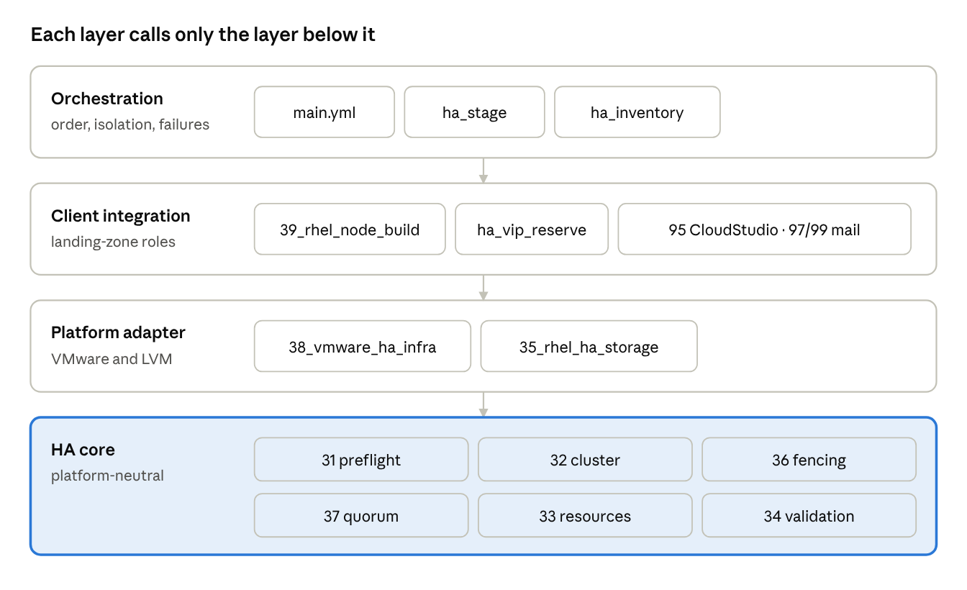
architecture layers · 4 layers, role names
The highlighted HA core is the part that survives a change of hypervisor or landing zone.

5. End-to-end process flow
main.yml is a sequence of plays. Play tags select a phase while testing (--tags allocate, provision, configure, ha_core, validate, close); init, gate and close plays are tagged always. Three kinds of host take part: localhost (cluster-scope work), ha_builders (the virtual <node>-build hosts, per-node work through the standalone roles) and rhel_ha_nodes (the real nodes over SSH).
Play | Hosts | Does | Gate / marker
0 Validate | localhost | Controller preflight (31), register <node>-build hosts | stops on any input error
0 Init | ha_builders | Per-node control flags, node-scope and cluster-scope variables | none
1 Allocate (cluster) | localhost | Roles 04, 05, 08, 09 (DC, tier, network, golden image, folder); ha_vip_reserve; copy cluster-scope values to the node hosts | failmsg
1 Allocate (node) | ha_builders | Roles 03, 06 datastore, 06 host, 07, 07 second (name, datastore, IP/DNS) | ha_phase_ok = allocate
2 Provision | ha_builders | Roles 10, 11, 12: VM created powered off, NIC, private disks | ha_phase_ok = provision
2 VMware adapter | localhost | 38: anti-affinity rule, shared disk on node 1 then attached to node 2 | failmsg
3 Configure | ha_builders | Roles 13 (power on), 28, 14, 29, 30, 16, 18, 20-24, 26, 27; 15 optional | ha_phase_ok = configure
3 Register | localhost | Add the real nodes (SSH, IP from the build host) | assertion on IPs
4 Node readiness | rhel_ha_nodes | Node preflight (31), shared storage OS side (35) | ha_phase_ok = node_ready
4 Cluster | rhel_ha_nodes | 32 cluster, 36 fencing, 37 quorum, 33 resources, 34 build validation; opt-in fencing and failover tests | ha_phase_ok = ha_core
5 Close | localhost | Facts for the pair, CloudStudio (95), success mail (97) or failure mail (99), final fail if anything failed | AAP job shows red on failure
A gate runs after each per-node phase. If any node recorded a failmsg, the first one is promoted to the cluster-level failmsg; if a node simply has no marker (unreachable, unhandled error), a generic message is raised. Every later stage skips while failmsg is set, so the run drains to the close play, sends the mail, and fails the job.
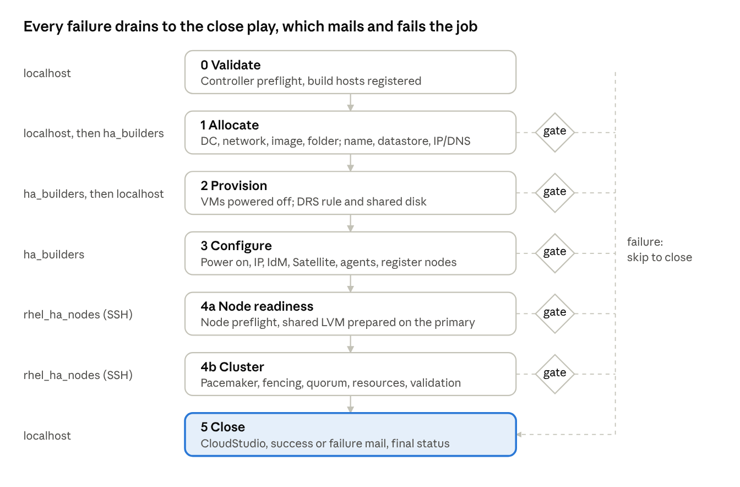
end-to-end flow · 6 phases, 5 gates
The gates are where per-node results become one cluster-level decision.

6. Node isolation and state model
The standalone roles keep their results as global facts on one host (servername, ip, is_vm_created, and about 30 more), guarded by <flag> is none. Two nodes run through the same host would overwrite each other. The design gives each node its own fact scope without touching the roles.
Mechanism. ha_inventory registers one virtual host per node, <node>-build, with ansible_connection: local and group ha_builders. Per-node plays run over that group, so each node has private facts and the existing guards behave as they do for a single VM. The real node is added later, once its IP exists, as a separate SSH host named <node>.
Scope | Lives on | Examples | Initialised from
Control flags | every host | nomsg, failmsg, failmail, sucmail | nomsg from localhost; failmsg reset per node
Node scope (ha_node_scope_vars) | <node>-build | servername, datastorename, hostname, ip, ip2, is_vm_created, network_configured, ip_configured, satellite_onboard, opsramp_onboarding, backupserverip | rhel_ha_nodes[].state, else an existing variable (extra_vars), else None
Cluster scope (ha_cluster_scope_vars) | localhost, copied to every node host after allocation | clustername, dcname, securityzonename, VLAN ids, subnetmask, gateway, dns1/2, goldenimagename, target_folder, vm_cpu, vm_ram_mb | Cluster allocation (roles 04, 05, 08, 09)
Cluster results | localhost | ha_vip_reserved, rhel_ha_result, cs_resources | Close play
State ledger. rhel_ha_nodes[].state is a map of node-scope variables. A caller that already has a node (or a half-built one) puts its known facts there, and the guards skip the roles that are done. This is the same resume mechanism as the standalone extra_vars, expressed per node.
Known risk. A standalone role that addresses localhost explicitly, or reads hostvars['localhost'], will not be isolated. This is unproven for the real roles and is the first spike (section 15): run role 03 and role 07 on two build hosts and compare their facts. If it fails, the fallback is to run the per-node phases through a loop over nodes with the facts saved and restored between iterations (serial, slower, but needs no assumption about the roles).
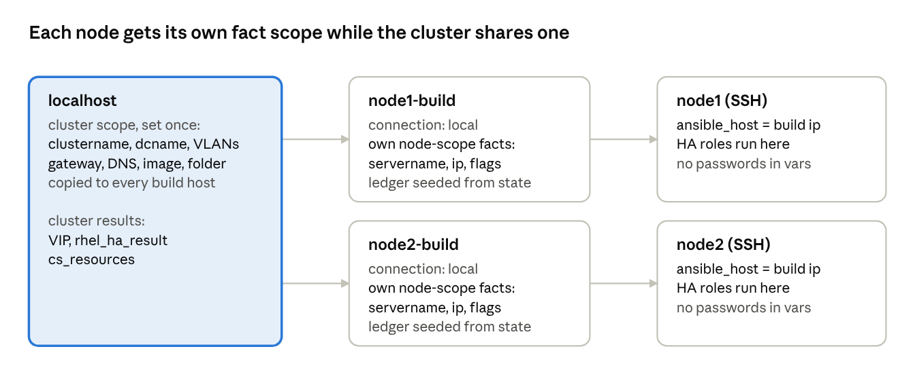
node isolation · localhost, 2 build hosts, 2 real nodes
The build host exists from the first allocation; the real node only after the IP is known.

7. Failure handling and resume
The design keeps the standalone convention: a failure sets failmsg (an HTML message addressed to the owning team), failmail: true and sucmail: false; every later stage skips while failmsg differs from nomsg; a failure mail goes out; the operator fixes the cause and relaunches with updated extra_vars.
Mechanism | Behaviour
Stage runner (ha_stage) | Runs one role inside block/rescue. On failure a single task writes failmsg, failmail, sucmail (one task on purpose: a second task would be evaluated against the new failmsg). Existing failmsg is never overwritten.
Failure message | Team and instruction per stage, job link (templ_link), failed task name, error text, and the exact <stage>_done: true flag to set if the step was completed by hand. All user-derived text is HTML-escaped.
Gate | After each per-node phase: collects failmsg from every node and promotes the first to the cluster; a node without the phase marker produces a generic message.
Skip rule | Stages run only while the cluster failmsg is nomsg, the host's own failmsg is nomsg, the stage's ha_stage_when is true and its done flag is not set.
Close | Always runs (tag always): facts, CloudStudio, success mail or failure mail, then an explicit fail so AAP shows the job red.
Resume | Relaunch with the completed stages' flags and any node state: cluster_allocate_done, node_allocate_done, node_provision_done, vmware_ha_infra_done, node_configure_done, ha_cluster_done, ha_fencing_done, ha_resources_done, ha_vip_reserved_done.
Verified locally (tests/run_tests.sh): a passing stage sets its flag; a done flag skips the stage; a failing stage fills failmsg with the escaped error and team; later stages skip; a gate promotes a node failure and detects a missing marker.
Not automated: the flags are not emitted by the job (no set_stats); the operator copies them into the relaunch. Emitting a ready-to-paste extra_vars block into the mail is a worthwhile follow-up and is cheap to add in the stage runner.
Resume is only as good as idempotence. The HA roles detect existing state (existing cluster name, existing resources, existing VG) and skip or refuse; the standalone roles rely on their own guards.
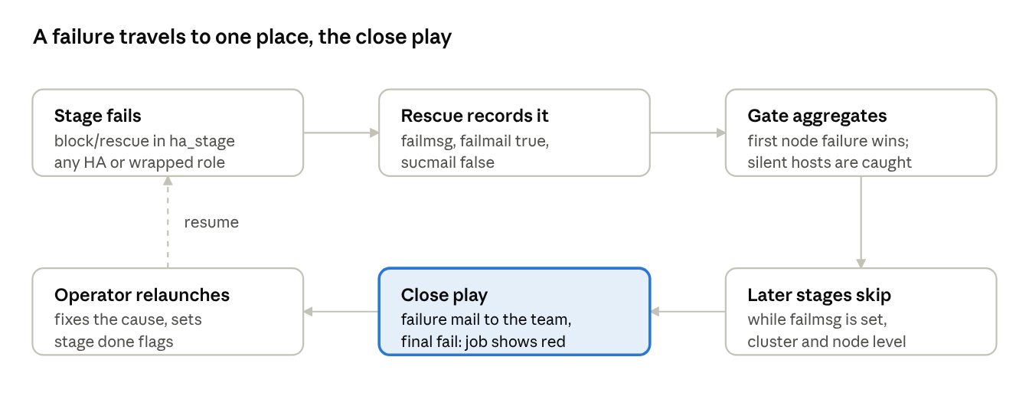
failure path and resume · 6 steps
The dashed line is the only manual step: the operator decides what was fixed.

8. Role catalogue
New roles use numbers 31-39 (HA) and plain names for helpers. Run-on says where the role executes.
Role | Layer | Run on | Does | Key inputs | Outputs
ha_stage | Orchestration | any | Stage runner, gate, close facts | ha_stage_name, ha_stage_role, ha_stage_team, ha_stage_done_var, ha_stage_when | failmsg, failmail, sucmail, done flags, cs_resources, mail inputs
ha_inventory | Orchestration | localhost, ha_builders, real nodes | Virtual build hosts, per-node variable init, real node registration | rhel_ha_nodes, scope lists | <node>-build, rhel_ha_nodes group, ha_primary_node
39_rhel_node_build | Client integration | localhost, ha_builders | Phase wrapper around the standalone roles (cluster_allocate, node_allocate, node_provision, node_configure) | standalone inputs | standalone facts
ha_vip_reserve | Client integration | localhost | Validates the VIP and its DNS record (provided mode); BlueCat mode not implemented | ha_vip | ha_vip_reserved
31_rhel_ha_preflight | HA core | localhost, nodes | Input validation (controller scope), node readiness (node scope) | ha_* inputs | pass or stop
32_rhel_ha_cluster | HA core | nodes | Packages, firewall, pcsd, pcs host auth, cluster setup, wait for both nodes online | ha_cluster_name, nodes | running cluster
36_rhel_ha_fencing | HA core | nodes | Stonith device (fence_vmware_rest, fence_scsi or lab none), fence tests | ha_fencing | stonith resource
37_rhel_ha_quorum | HA core | nodes | Asserts two-node quorum flags | none | pass or stop
35_rhel_ha_storage | Adapter (OS side) | nodes | LVM system_id, VG/LV/filesystem on the primary, refusal on foreign signatures | ha_storage | prepared shared volume
33_rhel_ha_resources | HA core | nodes | Ordered resource group: LVM-activate, Filesystem, IPaddr2 VIP, application resources | ha_vip, ha_storage, ha_resources | resource group
34_rhel_ha_validation | HA core | nodes | build, health and failover modes: quorum, nodes, stonith, resource state, VIP location | ha_validation_mode | rhel_ha_result
38_vmware_ha_infra | Adapter (VMware) | localhost | vCenter selection, DRS check, anti-affinity rule, shared disk | dcname, clustername, ha_storage | ha_drs_rule_applied, ha_shared_disk_path
95_*, 97_* (patched) | Client integration | localhost | CloudStudio update and success mail for the pair | cs_resources, mail_extra_html, banner vars | unchanged contract

9. Interfaces
One input structure, validated by 31_rhel_ha_preflight before anything is allocated. Standalone inputs (deploymenttype, metalcategory, ostype, environmenttype, addontype, additionaldrives, ...) are passed through unchanged. Secrets are never inputs: they arrive as AAP credential injectors.
Input | Shape | Rules enforced at preflight
rhel_ha_nodes | list of exactly two {name, ip?, state?} | unique names matching ^[A-Za-z0-9][A-Za-z0-9-]*$; IPv4 if given; state is a map
ha_cluster_name | string | [A-Za-z0-9_-], at most 32
ha_backend | pcs | system_role refused (not built)
ha_vip | {address, name, cidr_netmask?} | valid IPv4, DNS name present, netmask 8-32; DNS must resolve to the address
ha_fencing | {type, vcenter_host?, devices?, ssl_verify?} | fence_vmware_rest needs vcenter_host; fence_scsi needs devices; none and ssl_verify: false only with ha_lab_mode
ha_lab_mode | bool | refused unless environmenttype is set and not production
ha_quorum | {} | qdevice refused
ha_storage | {model, device, size_gb, datastore, mount, vg_name?, lv_name?, lv_size?, fstype?} | model none or shared_lvm; device under /dev/; real fencing required; device not in additionaldrives
ha_run_disruptive_tests, ha_maintenance_confirmed | bool | disruptive tests need confirmation
ha_skip_mail, ha_skip_cloudstudio | bool | test aids
Credentials (AAP injectors): vCenter VMWARE_HOST_1/_2, VMWARE_USER_1/_2, VMWARE_PASSWORD_1/_2, optional VMWARE_VALIDATE_CERTS_1/_2; fencing VMWARE_FENCE_USER, VMWARE_FENCE_PASSWORD; CloudStudio cs_uri, cs_key; SMTP variables for mail; a Machine credential for SSH.
Result: rhel_ha_result (quorate, node states, resource placement, failover tested) feeds the success mail; cs_resources carries one entry per node to CloudStudio.

10. Reuse and repackage map
The full task-by-task map is in the workbook RHEL_HA_Reuse_Map_and_Design.xlsx (sheets Role Map, HA Flow, Reuse Map, Summary, Design, Open Items). Summary of its 55 rows:
Verdict | Rows | Meaning
Reuse as-is, per node | 20 | Standalone role runs once per node on its <node>-build host
Reuse as-is, once per cluster | 10 | Standalone role runs once on localhost (DC, network, image, folder, debug, ...)
Repackage | 8 | site.yml wrapper, 03 (pair naming), 07 (VIP without VM), 30 and 21 (input-only), 15 (decide), 95, 97
New | 15 | HA core, adapter, orchestration roles
Not applicable | 2 | Standalone-only steps with no HA equivalent
Confidence. Source for 7 of about 38 roles has been read (04, 06 host selection and wrapper, 95, 97, the defaults ledger). The other reuse verdicts rest on role names and site.yml guards. Treat "reuse as-is" for an unseen role as a hypothesis until its code is reviewed; the owner column in the workbook lists whom to confirm with.
Repackaged roles delivered: 95 (cs_resources list, 2xx handling, optional no_log) and 97 (extra HTML block, banner text, defaults for completed_at/statuslink, optional mail error tolerance), each as a full replacement plus a diff against the original. Both keep standalone behaviour when the new variables are unset.

11. HA core detail
The core is a Pacemaker/Corosync active/passive pair with one resource group on shared LVM storage. Each step stops the run on its own failure; nothing continues on a half-built cluster.
Step | Role | Guards and idempotence | What it proves
Node preflight | 31 (node scope) | RHEL 8.4 or later; hostname equals the inventory name; peer names resolve without loopback; pcs available from the configured repos; chronyd running; no foreign cluster already on the node | The node can join a cluster before anything changes
Shared storage | 35 | system_id_source = "uname" in lvm.conf, initramfs rebuilt without reboot; refuses a mounted device or a foreign signature; VG, LV and filesystem created on the primary only; VG deactivated; pvscan --cache on the secondary | The disk is owned by one node at a time and Pacemaker, not boot, activates it
Cluster | 32 | Detects an existing corosync.conf and its cluster name (same name: continue; other name: stop); installs pcs, pacemaker, corosync, resource-agents and the fence agent package; opens the high-availability firewalld service; ephemeral 40-character hacluster password used for pcs host auth, then rotated; pcs cluster setup --start --enable; waits until both nodes are online | A two-node cluster exists and survives reboot
Fencing | 36 | Agent tested per VM (status) before the stonith device is created; device by type (fence_vmware_rest, fence_scsi, lab none); optional tests list devices and fence node 2 (gated) | A node can be powered off by its peer
Quorum | 37 | corosync-quorumtool: quorate, 2Node, WaitForAll, expected votes 2 | Split brain is handled by fencing, not by guessing
Resources | 33 | Refuses to run without stonith (unless lab); creates only missing resources, in one ordered group rg_<cluster>: LVM-activate, Filesystem, IPaddr2 VIP, application resources; each with --wait | The service starts as a unit, in order, on one node
Validation | 34 | build: quorum, both nodes online, stonith effective, every expected resource started (from crm_mon XML), VIP on exactly one node and resolvable. failover (opt-in): move the group to the peer and back, clear the constraint, clean up, re-assert. health: non-disruptive re-check | Failover works, and the cluster is left clean
Unverified until the lab run: the exact crm_mon XML attributes and the pcs status nodes text used by the wait loops on your RHEL 8 minor; fence_vmware_rest option names (the role reads them from pcs stonith describe, but the first run must confirm them).
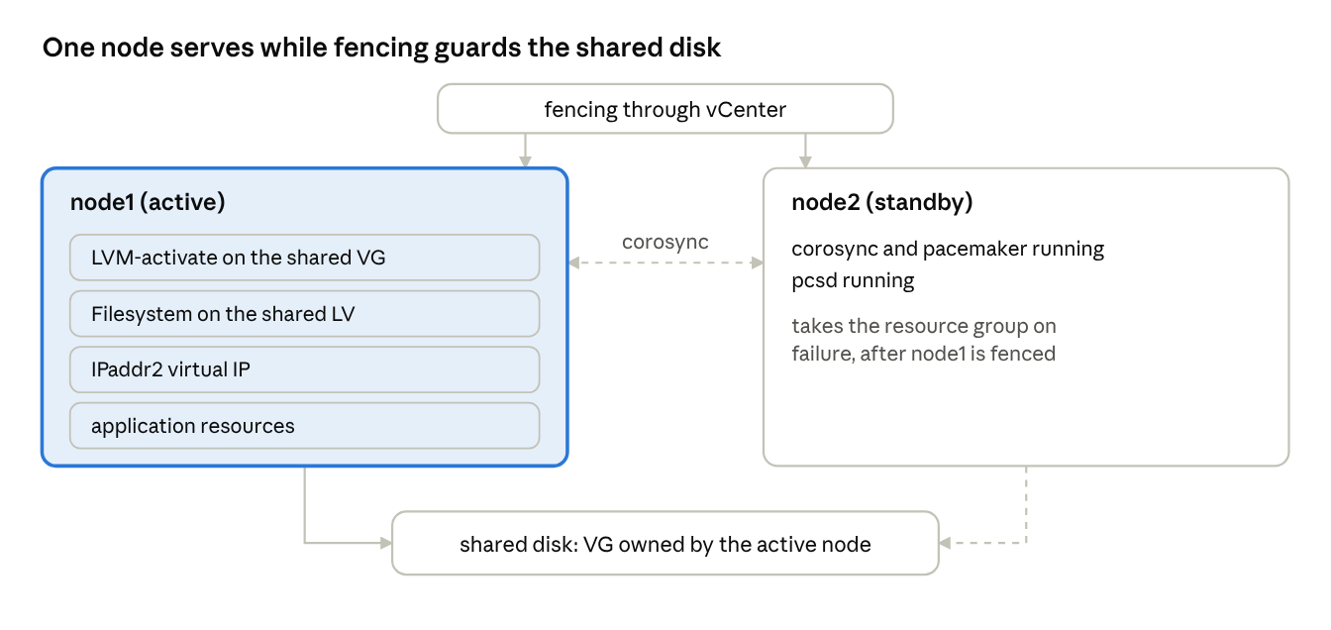
cluster topology · 2 nodes, 1 resource group, shared disk
The dashed link to node 2 is the standby path: the VG is only activated there after fencing.

12. VMware adapter
38_vmware_ha_infra runs on localhost after both VMs exist (powered off) and before the first power-on, which happens in role 13 during the configure phase.
Step | Behaviour | Notes
vCenter selection | VMWARE_HOST/USER/PASSWORD_1 or _2 chosen by dcname; certificates validated unless the injector says otherwise; all calls no_log | Stricter than role 10, whose validate_certs default is false
DRS check | Cluster must have DRS enabled and fully automated, otherwise the rule is not enforced at power-on | Uses vmware_cluster_info, deprecated in community.vmware 6.x; ha_check_drs: false skips
Anti-affinity rule | ha-anti-affinity-<cluster>, mandatory, enabled, the two node VMs | Created idempotently
Shared disk | Eager-zeroed thick, multi-writer, independent persistent, paravirtual controller 1 unit 0, on the datastore named in ha_storage; created on node 1, the same VMDK attached to node 2 | Existing disk on that controller/unit is detected and reused
vSphere HA | Reports a reminder: the VM restart override is manual | No module exists for it
Assumptions to confirm: the mapping from dcname to vCenter and datacenter name (written to match the naming role 10 uses, but role 10's code has not been read); that the target datastore supports multi-writer disks (VMFS or vSAN as the storage team confirms; NFS does not); that the existing-disk detection by controller/unit matches how the VMware team numbers controllers.
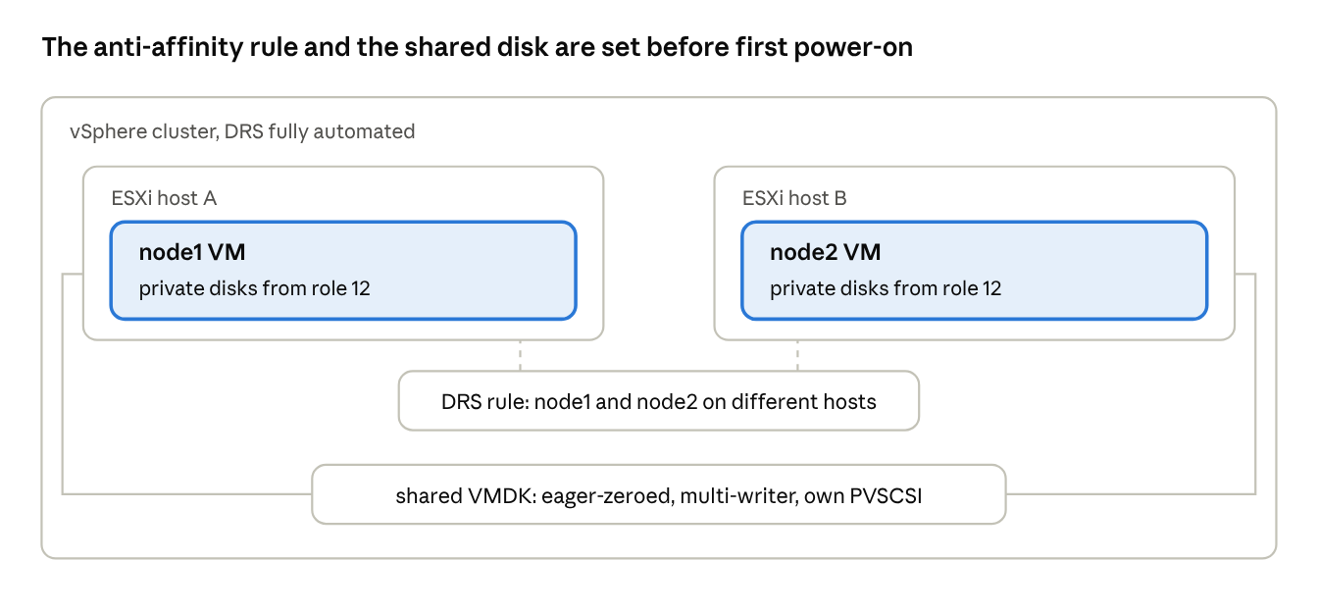
VMware adapter · rule and shared disk across 2 hosts
The disk is created once on node 1 and attached to node 2; both VMs stay powered off until the rule exists.

13. Security and compliance design
Area | Design | Gap or deviation
Secrets | Only AAP credential injectors; no passwords in inventory, host vars or mail. hacluster password is random, ephemeral and rotated. Fence password reaches the node through a root-only script and is never stored in the CIB. vCenter calls are no_log. | CloudStudio key in role 95 is logged unless cs_no_log: true; recommend setting it in AAP
Least privilege | Separate vCenter identities recommended: adapter account (VM reconfigure, DRS rule) and fence account (power operations on the two VMs only, via a custom role) | The standalone VMware identity is likely broader; the fence account must be created by the VMware team
Fencing | Mandatory. none and ssl_verify: false need ha_lab_mode, which is refused for production environment types and when environmenttype is empty | Lab mode is a control only as strong as the environmenttype input
Destructive operations | Storage role refuses a mounted or foreign-signature device; fencing and failover tests need both ha_run_disruptive_tests and ha_maintenance_confirmed | Maintenance window in OpsRamp is a human step
Network | high-availability firewalld service only; no other ports opened | Cluster traffic assumed on the primary VLAN; a dedicated heartbeat network is not designed
SSH | Machine credential from AAP; StrictHostKeyChecking=accept-new for fresh VMs | Trust on first use; accepted for new builds only
Mail | All error text and user input HTML-escaped; job link from templ_link | Failure mail may still expose internal host names to the team addressed
Tagging and ownership | Inherited from the standalone roles (folder, tags, CMDB entry per node) | Cluster-level object in Valuemation is not designed (open item)

14. Test strategy
Level | What | Where | Status
0 Static | yamllint, ansible-lint (moderate profile), --syntax-check of main.yml | Anywhere | Clean
1 Local logic | tests/run_tests.sh: stage runner (success, resume, failure, skip), gate (failure, missing marker), controller preflight (example accepted, 13 bad inputs rejected), patched 97 rendering the cluster block, syntax | Anywhere, no infrastructure | 18 of 18 pass
2 Role by role | --tags validate, allocate, provision, configure, ha_core with ha_skip_mail and ha_skip_cloudstudio; skipped phases supplied as extra_vars | Lab vCenter and two lab VMs | Not run
3 Isolation spike | Roles 03 and 07 on two build hosts; compare facts | Lab | Not run: first thing to do
4 Disruptive | Fence node 2, fail over and back, quorum loss behaviour | Lab, maintenance confirmed | Not run
5 Regression | Standalone site.yml unchanged with patched 95 and 97 (new variables unset) | Non-prod | Not run
Suggested order for level 2: allocate (read-only decisions, cheapest), provision (check the multi-writer disk and the DRS rule in vCenter before going on), configure, then ha_core on two throwaway RHEL VMs first (no vCenter needed with fence_scsi or lab mode) to prove the core independently of the adapter.

15. Risks, open items and spikes
# | Risk or open item | Impact | Action / owner
R1 | Node isolation untested with the real roles | High: the orchestration model depends on it | Spike 1 (level 3). Fallback: serial per-node loop with saved facts
R2 | Source read for 7 of about 38 roles | Medium: reuse verdicts are hypotheses | Satish to supply code for 06 datastore, 07, 07 second, 05, 08, 09, 11, 12, 13, 14, 15, 28, 29, 30, 98, 99 and tasks/main.yml
R3 | Role 07 may be bound to a VM | Medium: VIP reservation is manual (provided mode) | Read role 07; else a small BlueCat client role
R4 | Role 03 names from the AAP job ID (step 10) | Medium: pair naming undecided | Decide a rule (for example name and name+1); until then explicit names
R5 | Fencing prerequisites: vCenter reachable from both nodes, a power-only account, certificate trust | High: no fencing, no shared storage | VMware and security teams
R6 | Multi-writer disk support on the target datastore | High | Storage team to confirm datastore type per tier
R7 | vSphere HA VM override is manual | Low-medium | Runbook step, reported by role 38
R8 | pcs and crm_mon output differs between RHEL 8 minors | Medium: wait loops and assertions | Confirm in the first lab run; adjust parsing
R9 | Late failure leaves onboarded nodes (D12) | Medium | A decommission or rollback path is not designed
R10 | Two-node cluster without qdevice | Medium: fencing outage blocks failover | Qdevice as a later option; refused by preflight today
R11 | vmware_cluster_info deprecated | Low | Replace when a successor is chosen; check can be skipped
R12 | Where completed_at, statuslink, email_to and nomsg are defined | Low | Close play sets completed_at; confirm the others
Not designed: active/active storage, cluster filesystems (GFS2), stretched clusters across DC1 and DC2, qdevice, the RHEL system-role backend, automatic extra_vars emission in the failure mail, cluster-level CMDB object, decommissioning.

